**How to Get Your Defensive Driving Certificate**

1. Go to: <http://ehs.uc.edu/itc/>
2. 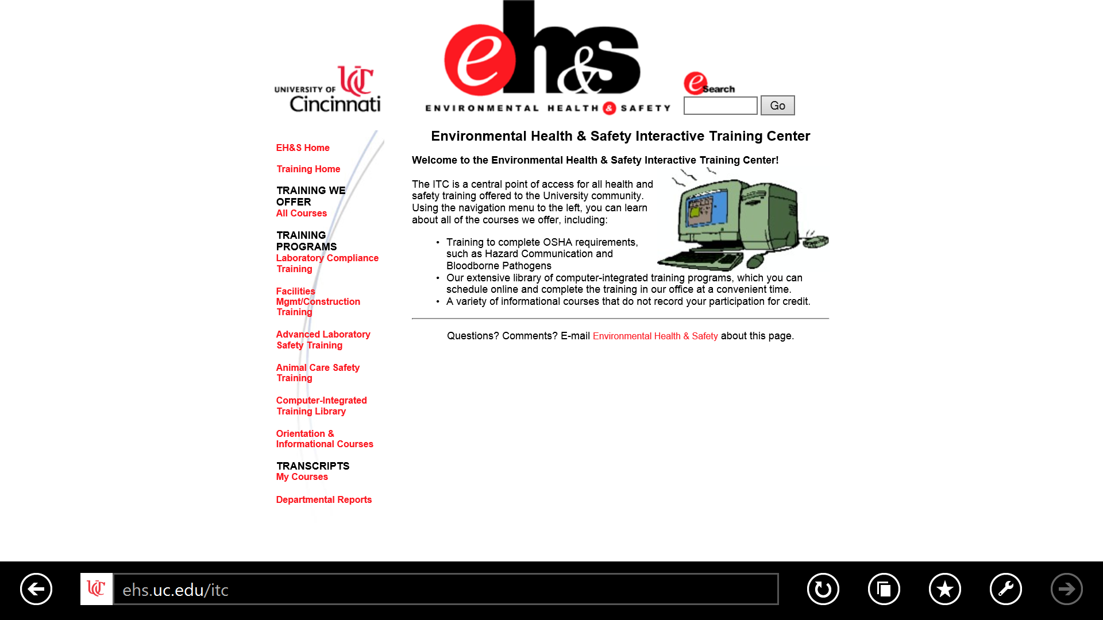Click “**All Courses**”
3. 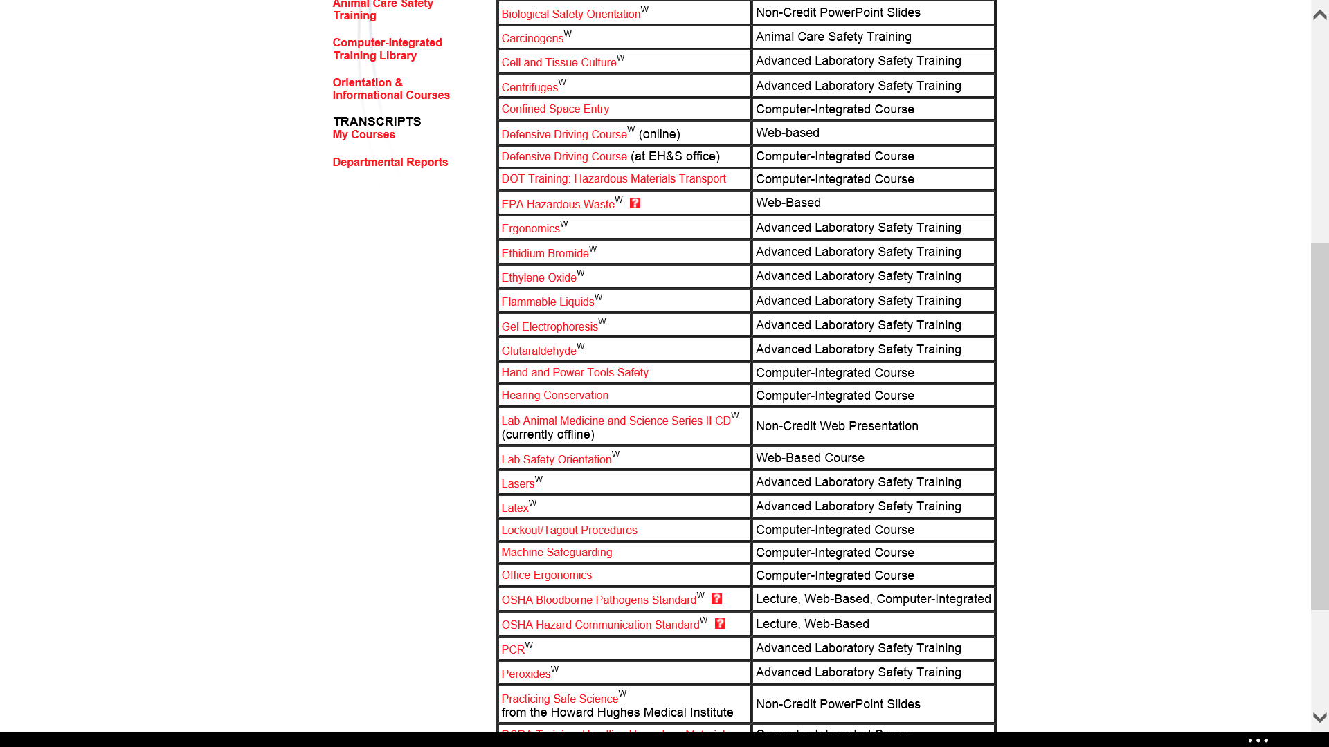Click “Defensive Driving”
4. 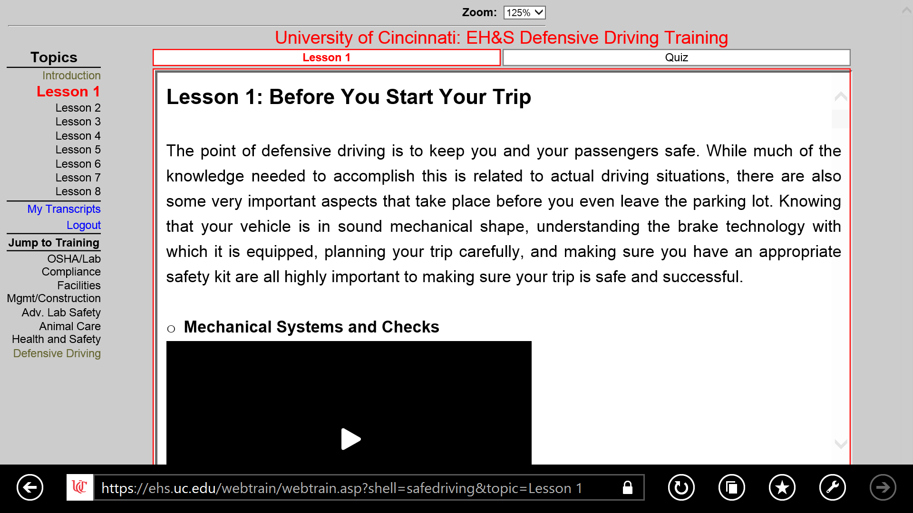You will have to log in and then be directed to a screen like this. Click the “**Defensive Driving**” Button and complete the information on screen. Then, complete all lessons and quizzes.
5. 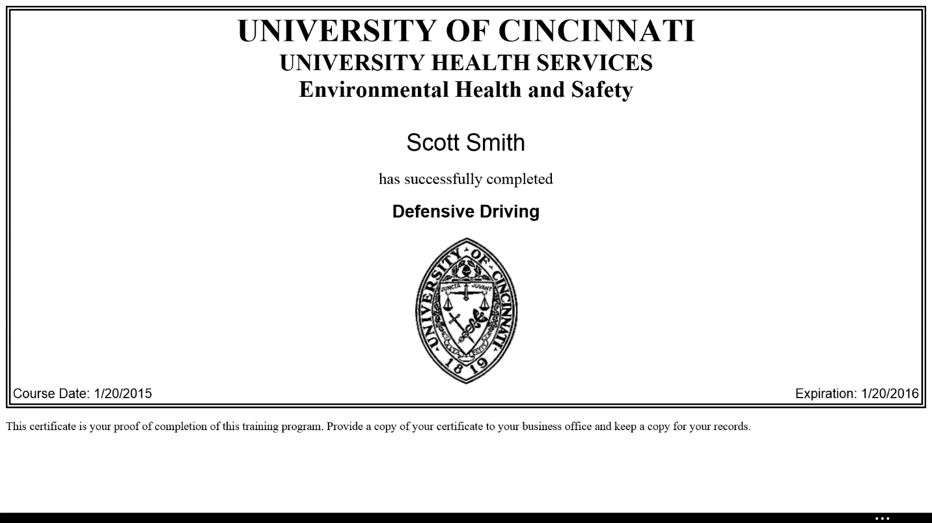Once completed, Print 2 copies of your certificate. Keep one in safe place and give the other to the Treasurer. This is required if you plan on being a driver!